3.1 GENERATION OF PHASE MODULATED (PM) SIGNALS AND CALCULATION OF PHASE DEVIATION USING MATLAB SIMULATION
PROGRAM (MATLAB CODE)
clc;
clear;
close all;
% Parameters
Am = 1; % Message Amplitude (V)
fm = 100; % Message Frequency (Hz)
Ac = 5; % Carrier Amplitude (V)
fc = 1000; % Carrier Frequency (Hz)
fs = 20*fc; % Sampling Frequency (Hz)
kp = pi/2; % Phase Sensitivity (rad/V)
% Time Vector

t = 0:1/fs:4/fm;
% Message Signal
m = Am*sin(2*pi*fm*t);
% Carrier Signal
c = Ac*cos(2*pi*fc*t);
% Phase Modulated Signal
pm = Ac*cos(2*pi*fc*t + kp*m);
% Phase Deviation
phase_dev = kp*Am;
% PM Modulation Index
mp = phase_dev;
% Display Results
fprintf('Message Amplitude = %.2f V\n',Am);
fprintf('Message Frequency = %.0f Hz\n',fm);
fprintf('Carrier Amplitude = %.2f V\n',Ac);
fprintf('Carrier Frequency = %.0f Hz\n',fc);
fprintf('Phase Sensitivity = %.2f rad/V\n',kp);
fprintf('Phase Deviation = %.2f radians\n',phase_dev);
fprintf('PM Modulation Index = %.2f\n',mp);
% Plotting
figure('Name','Phase Modulation and Phase Deviation',...
'NumberTitle','off');
subplot(2,2,1);
plot(t,m,'LineWidth',1.5);
title('Message Signal');
xlabel('Time (s)');
ylabel('Amplitude');
grid on;
subplot(2,2,2);
plot(t,c,'LineWidth',1.5);
title('Carrier Signal');
xlabel('Time (s)');
ylabel('Amplitude');
grid on;
subplot(2,2,3);
plot(t,pm,'LineWidth',1.5);
title('Phase Modulated Signal');
xlabel('Time (s)');
ylabel('Amplitude');
grid on;

subplot(2,2,4);
bar(phase_dev);
title('Phase Deviation');
ylabel('Radians');
set(gca,'XTickLabel',{'PM Signal'});
grid on;

OUTPUT:
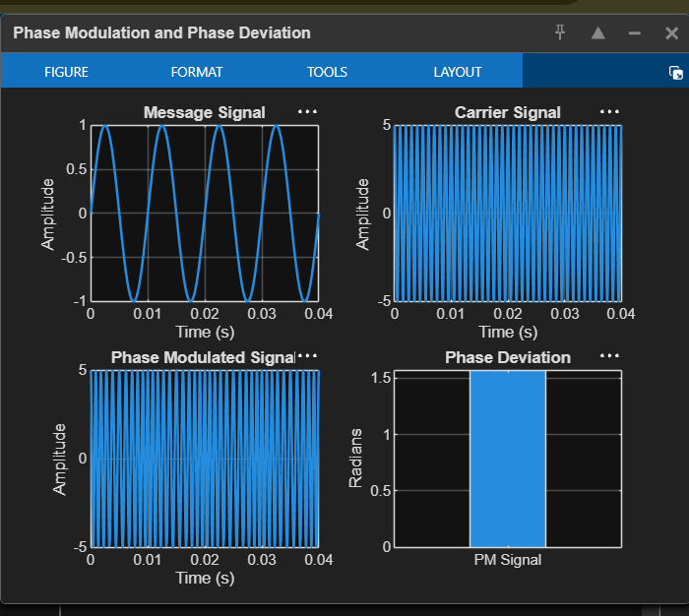

Exp NO: 3.2 POWER SPECTRAL DENSITY (PSD) ANALYSIS OF PHASE
MODULATED (PM) SIGNALS USING MATLAB
Objectives
i) To generate a Phase Modulated (PM) signal in MATLAB using specified carrier and message
signal parameters.
ii) To compute the frequency spectrum of the PM signal using the Fast Fourier Transform (FFT).
iii) To calculate and plot the Power Spectral Density (PSD) of the PM signal using MATLAB.
iv) To identify the carrier component and sideband frequencies present in the PM spectrum.
v) To analyze the effect of phase modulation on the spectral distribution and bandwidth of the
transmitted signal.
vi)To investigate the influence of modulation index on the Power Spectral Density characteristics
of the PM signal.
PROGRAM (MATLAB CODE)
clc;
clear;
close all;
% Parameters
Am = 1; % Message Amplitude (V)
fm = 100; % Message Frequency (Hz)
Ac = 5; % Carrier Amplitude (V)
fc = 1000; % Carrier Frequency (Hz)
fs = 20*fc; % Sampling Frequency (Hz)
kp = pi/2; % Phase Sensitivity (rad/V)
% Time Vector
t = 0:1/fs:4/fm;
% Message Signal
m = Am*sin(2*pi*fm*t);
% PM Signal
pm = Ac*cos(2*pi*fc*t + kp*m);
% Phase Deviation
beta = kp*Am;
% FFT
N = length(pm);
f = linspace(-fs/2,fs/2,N);
PM_FFT = abs(fftshift(fft(pm)))/N;
% Power Spectral Density

PSD = (abs(fftshift(fft(pm))).^2)/(N*fs);
% Approximate Bandwidth
BW = 2*(beta+1)*fm;
fprintf('Phase Deviation = %.2f radians\n',beta);
fprintf('Estimated Bandwidth = %.2f Hz\n',BW);
% Plotting
figure('Name','PSD Analysis of PM Signal','NumberTitle','off');
subplot(2,2,1);
plot(t,m);
title('Message Signal');
xlabel('Time (s)');
ylabel('Amplitude');
grid on;
subplot(2,2,2);
plot(t,pm);
title('Phase Modulated Signal');
xlabel('Time (s)');
ylabel('Amplitude');
grid on;
subplot(2,2,3);
plot(f,PM_FFT);
title('Frequency Spectrum of PM Signal');
xlabel('Frequency (Hz)');
ylabel('Magnitude');
grid on;
subplot(2,2,4);
plot(f,PSD);
title('Power Spectral Density');
xlabel('Frequency (Hz)');
ylabel('PSD');
grid on;

OUTPUT:
